

Guidance for the use of a Power/Safety Boat at RSC
These guidance notes are not to be used for training or instruction but to act as an aide memoir ensuring that when suitable club members are engaged in a safety boat duty, they have a short form set of notes as guidance.
- The purpose of club power boats is to act as safety, training and or Committee vessels for RSC activities, or in support of similar activities approved by a Flag Officer / OOD. They are not to be used for any other recreational activity for example water skiing or towing inflatable toys.
- The OOD gives final approval for all power boat operations and must be kept informed at all times of their use and whereabouts.
- The OOD is responsible for co-ordinating and allocating safety boat duty during the sailing / racing day.
- Only members who have read these guidance notes and consider themselves capable of operating a safety boat should operate one. They should also read the RYA Safety Boat Handbook, and be aware of the contents of it.
- Buoyancy aids must be worn in line with RSC’s byelaws
- Fuel Handling;
6.1. There is to be no smoking in the vicinity of the fuel cabinets, near fuel cans or whilst on board a power boat.
6.2. Clean fuel must be used along with the fuel additive; always use a funnel with a strainer. Never refuel in the boat, always refuel on land. If a spillage occurs thoroughly flush the area with clean water.
6.3. Before a power boat is used, drivers must ensure that the fuel tank is at least half full.
6.4. On completion of the days running the fuel tank must be topped up to at least half full from the green jerry cans stored in the fuel cabinets and the appropriate amount of fuel additive included.
6.5. The electric battery should be replaced on its charger so it recharges for the next session
6.6. Drivers should report any damage to a boat, engine or fuel tank (and any fuel shortages or problems) to the OOD or a Flag Officer.
- Duties of the OOD in respect of a safety boat;
7.1. Responsible for ensuring the availability of the safety boat at all times during the sailing / racing day. 7.2. Getting the boat ready for immediate use and checking seaworthiness.
7.3. Ensuring required equipment is aboard; Warp or towline to secure sailing boats, Two oars, First Aid kit which should be in a watertight container, Fuel tank secured and fuel line connected, Kill cord fitted and working, Bailer
7.4. Maintaining with the race team a watch over all craft on the water.
7.5. Ensure role of safety boat driver is allocated to assist boats and persons in difficulty.
- When using a power boat:
8.1. The engine should only be running when driver is seated in the driver’s position.
8.2. Do not stand whilst driving.
8.3. Do not leave the engine running whilst you go to the front of the boat.
8.4. Always use the kill cord.
- During power boat operations the driver should;
9.1. Regularly review wind strength and direction.
9.2. Maintain a watch and ensure all boats remain in sailing area.
9.3. Watch for boats in difficulty, and assist if possible.
9.4. Regularly check fuel level.
9.5. Always prioritise people over craft.
9.6. When moving alongside a person in the water the engine should be in neutral or switched off.
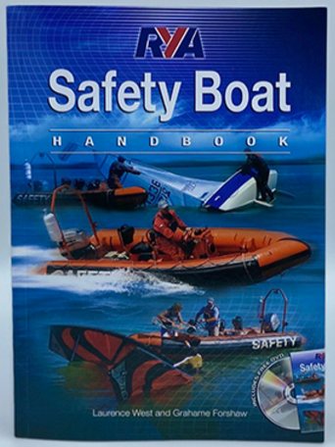
All drivers of a Safety Boat are encouraged to read and fully understand the contents of this RYA handbook, prior to undertaking a Safety Boat Duty.
A copy is in the club house.

